Linda Nan Bowie Jordan

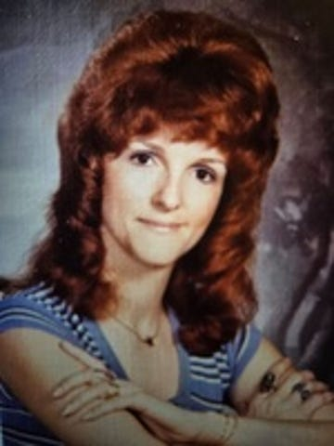

Linda Nan Bowie Jordan (January 22, 1942 January 14, 2025), age 82, of Port Orchard, died peacefully with her family by her side. Born in Bath, Maine to Vernon Taylor and Elizabeth Florence (Henderson) Bowie, the family moved to Port Orchard in 1945. Linda grew up primarily in Port Orchard, attending Frank Givens Elementary and Marcus Whitman Junior High. In 1956, the family moved to Bremerton where she graduated from West High School in 1960.

Linda met her first husband, Charles C. Miller (deceased), while working for Boeing in Seattle. They were married in 1961 and had three children. They later divorced.

In 1967, she married Robert Neal Thatcher (deceased). They divorced and in 1978, Linda married her forever love, John (Jack) Alton Jordan, a Navy pilot attached to the USS Kitty Hawk ported in Bremerton. The two of them found a deep and everlasting love.

Before leaving her job at Naval Supply Center (NSC), Bremerton and moving to Oak Harbor where Jack was stationed at NAS Whidbey, Linda was active in PTA, Fathoms of Fun, Girl Scouts, and Camp Fire Girls. She was a member of Beta Sigma Phi, United Methodist Church, several bowling leagues, and Bremerton Women’s Slow-pitch League. As a young girl, she was also a member of Rainbow Girls.

While Jack was in the Navy, Linda enjoyed travels to Japan, Korea, Guam, The Philippines, and Hawaii.

In 1986, she and Jack moved to Huntsville, Alabama, where he was a pilot with NASA. During their time in Huntsville, they were members of the United Methodist Church, bowling leagues, and did volunteer work for the Salvation Army, working the food wagon in impoverished neighborhoods, preparing meals for the mission house, and working at tornado devastated locations.

In 1991, while living in Huntsville, Linda took a solo genealogy trip to New England. There she met cousins she didn’t know existed and revisited with some she hadn’t seen in 40 years. This two-week trip turned into a two-and-a-half-month journey, travelling as far as Halifax, Nova Scotia and Prince Edward Island. It always amazed her that she did it by herself and came home safely.

Upon Jack’s retirement from NASA in 1996, they moved to Pine Grove, California where they spent seven years caring for Jack’s parents. While there, Linda did volunteer work with Hospice and worked the 2000 Census. After finishing her Census work in Amador County, she was selected to go to San Jose, Palo Alto, Sunnyvale, Gilroy, and Mountain View, CA, as part of a team of trouble-shooters sent to resolve problems.

In August of 2003, Linda and Jack returned to Kitsap County ready to enjoy retirement and be back with family. She enjoyed a simple life enriched with family and friends. Her greatest life joy was her children, grandchildren, siblings, and extended families. Being “Grandma” was one of her most cherished and enjoyable times. She absolutely adored her grandchildren and loved every minute of her time spent with them. In addition to family, what made Linda’s life extraordinary was the way in which she did the ordinary things ~ with kindness, generosity, and love. She had a quiet faith in the Lord that kept her strong.

Mom had more hobbies than she ever had time to devote to them. Through the years, her hobbies included bowling, playing slow-pitch, gardening, motorcycling, skiing, scrapbooking, genealogy, reading, fishing, playing cards and the Seattle Seahawks, but there was nothing she loved more than family.

She was preceded in death by her parents Elizabeth and Vernon Bowie and sister, Lois Brown.

She is survived by her husband Jack, children Charles Christian “Chris” Thatcher (Bryan Garrett) of Bremerton; Melinda Nan Flores (David) of Florida; Carol Elizabeth Ridings (Rob) of Kent; step daughters Tina Melanie Lanzinger (Fritz) and Dana Kirsten Evans (Reed) both of Bellingham; Grandchildren Derek (Jessica Johnston) and Connor Ridings both of Kent; Tyler Ridings (Alyssa) of SeaTac; Rigoberto Euceda (Emily Baer) of Bellevue; Armond Euceda (Chenoa) of New Mexico; Zach Podesta of Michigan; Madison Evans (Brett) and Layne Maggs (Alex) both of Bellingham; Kendall Hathaway (Garrett) of Seattle; Great Grandchildren Monroe and Van Evans; brothers David Craig Bowie and Vernon Taylor Bowie (Karen) both of Port Orchard; along with assorted in-laws, outlaws, extended family and friends, numerous nieces and nephews, and cousins in Vermont, New Hampshire, Connecticut, Massachusetts, California and Texas.

Burial will be at Tahoma National Cemetery in Kent.

Memorial donations may be made to Kitsap County’s Battered Women’s Shelter, a Domestic Violence Program.

A Celebration of Life will be held on Saturday, March 22, 1:00 p.m. at the Bremerton Elks Lodge: 4131 Pine Road NE, Bremerton.