**Chester (Chet) Meigs**

**BREMERTON** - It is with great sorrow that we inform family, friends and our community of the passing of our father, Chester W. Meigs. Dad was born in Sheldon Missouri on September 12, 1942, to Clifford Meigs and Ida Lois “Yates” Meigs. The family moved to Port Orchard when he was 8.

In 1956 he met Gladys Prigger, his future wife. They started dating in 1958. Dad Graduated from South Kitsap High School in 1960. Dad and mom were married in 1961, making their first home in Tacoma. They moved to Bremerton in 1966.

He joined his brothers, Max and Bill, in the Bremerton Fire Department December 18,1967, advancing to Fire Inspector in 1980. In 1989 he was promoted to Provisional Fire Chief, then to Fire Chief in 1990. He retired in December 1992.

He is survived by his 3 children, Anna Meigs, Steve (Sharon) Meigs, Becky (Dan) Stegman, 3 grandchildren, Kenny Covington, Stefanie Covington and Miles Meigs, 8 great grandchildren and 3 siblings, Freda Spain, Mable Rainey and Charlie Meigs.

Per his wishes there will be no services. Donations can be made to the Alzheimer’s Association in remembrance of Gladys Meigs.

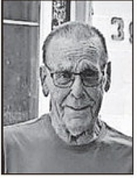

Died February 19, 2025